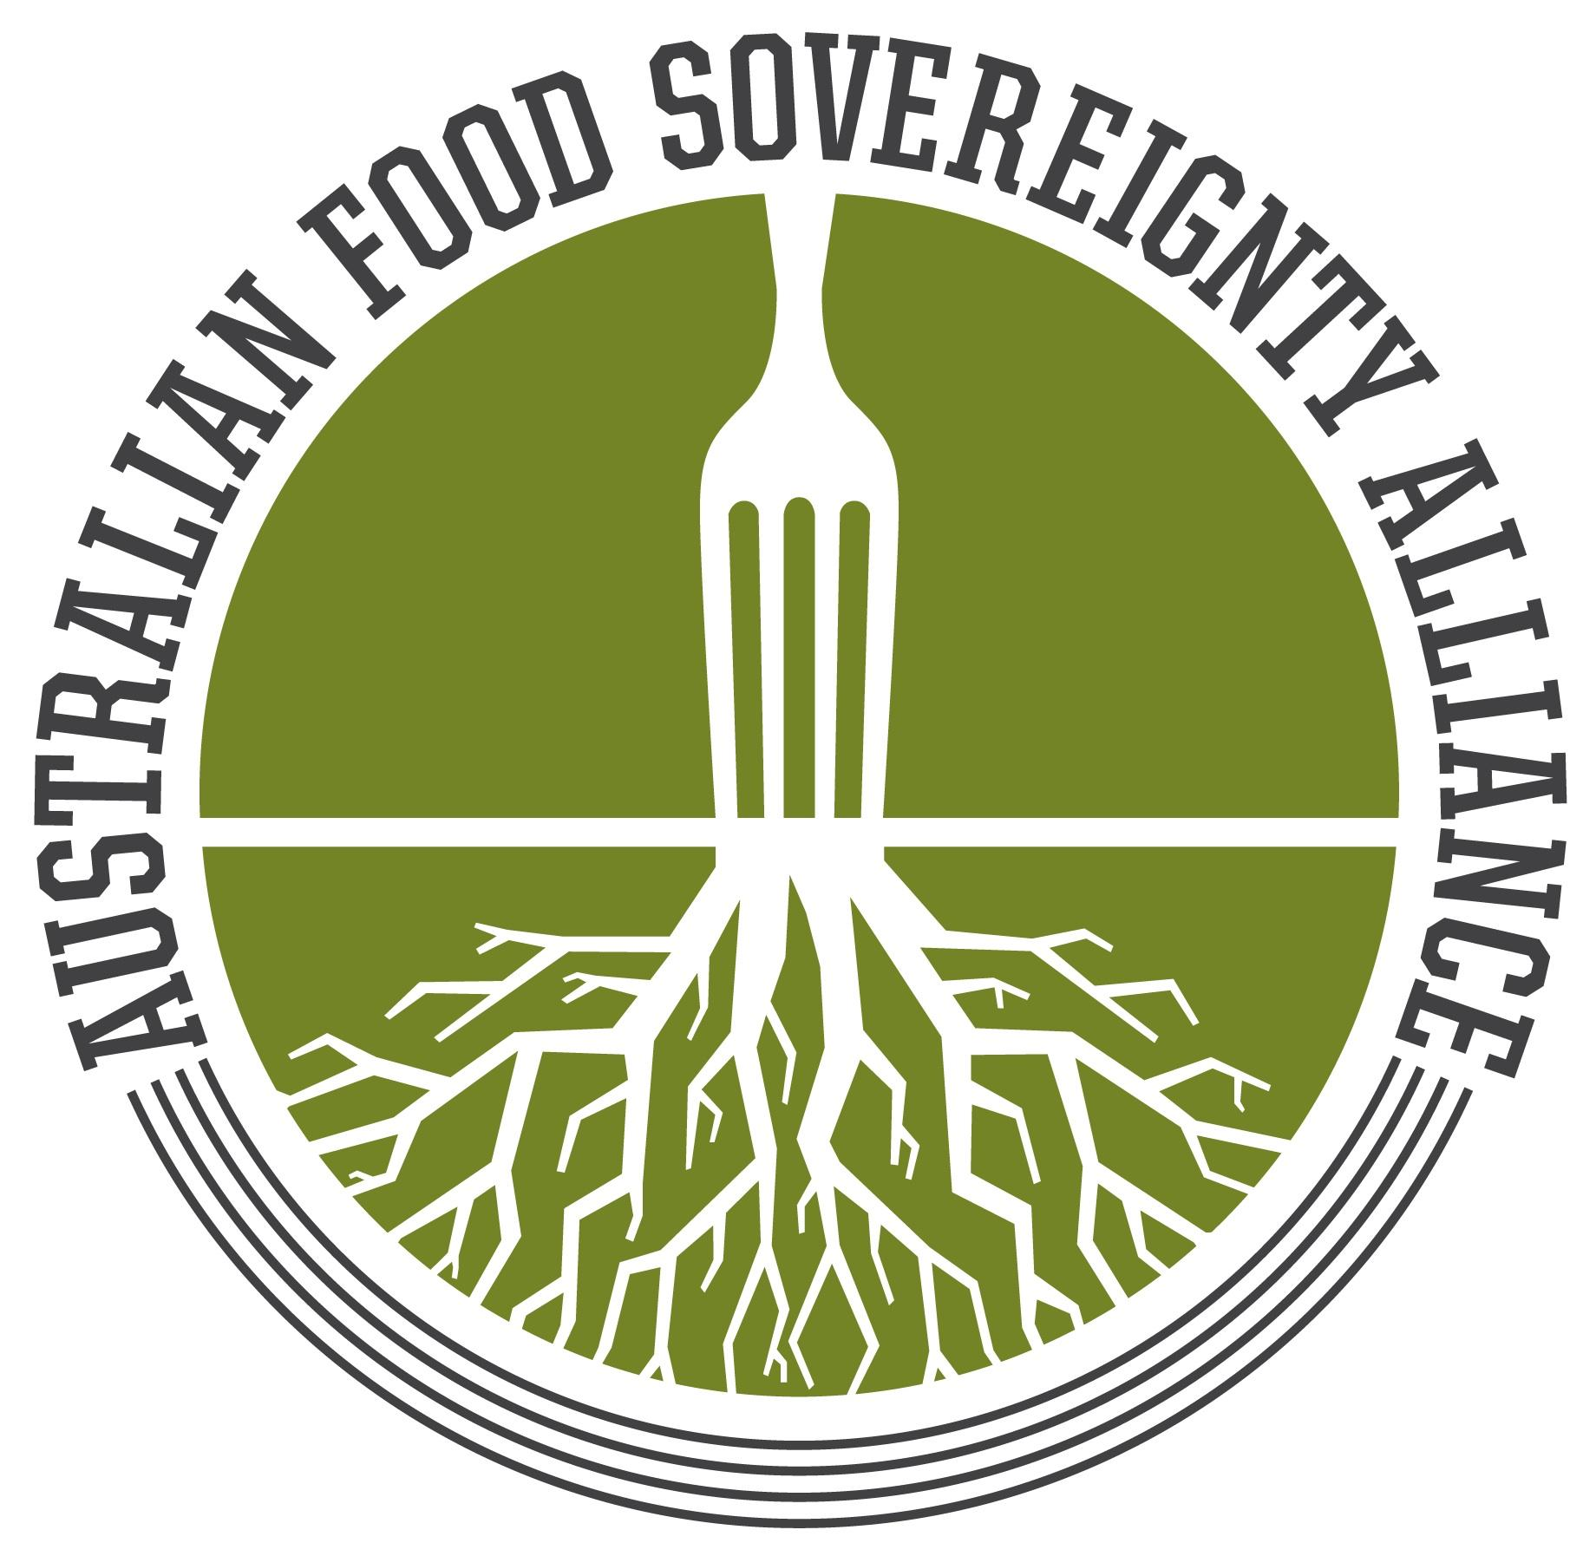
Australian Food Sovereignty Alliance

Response to the National Biosecurity Strategy - Consultation draft
Department of Agriculture, Water and the Environment
National Biosecurity Committee
18 March 2022

Tammi Jonas, Penny Kothe

We thank the committee for initiating the Consultation draft for the National Biosecurity Strategy. AFSA welcomes the opportunity to provide a written submission, as well as all further opportunities to participate in this consultation. We hope the committee will facilitate robust and meaningful stakeholder engagement across all aspects of the agricultural and food sector, prioritising the voices of First Peoples and those with lived experience of food production, biodiversity protection, and managing biosecurity on small-scale farms.

Table of Contents
Table of Contents 2
About the Australian Food Sovereignty Alliance 3
1. SCOPE OF THE STRATEGY 4
Shared biosecurity culture 8
Highly skilled workforce 11
Sustainable investment 11
Stronger partnerships 12
Coordinated preparedness and response 14
Integration supported by technology, research and data 14
2. ROLES WITHIN THE BIOSECURITY SYSTEM 15
3. BIOSECURITY RISKS AND OPPORTUNITIES 22
4. ACTIONS 23
Shared Biosecurity Culture 23
Highly Skilled Workforce 23
Sustainable Investment 23
Stronger Partnerships 23
Coordinated Preparedness and Response 24
Integration Supported by Technology, Research and Data 24
5. IMPLEMENTATION AND REVIEW 25

About the Australian Food Sovereignty Alliance

The Australian Food Sovereignty Alliance (AFSA) is a farmer-led civil society organisation of people working towards socially-just and ecologically-sound food and agriculture systems. The democratic participation of First Peoples, small-scale food producers and local communities in decision-making processes is integral to these efforts.

AFSA provides a balanced voice to represent small-scale food producers and local communities’ interests at all levels of government. We connect small-scale food producers for farmer-to-farmer knowledge sharing, assist local, state and the federal government in instituting scale-appropriate and consistent regulations and standards, and advocate for fair access for small-scale food producers to local value chain infrastructure and markets.

We are part of a robust global network of civil society organisations involved in food sovereignty and food security policy development and advocacy. We are members of the International Planning Committee for Food Sovereignty (IPC), La Via Campesina (the global movement of peasant farmers), and Urgenci (the International Network for Community-Supported Agriculture). We also support the Australasian representative on the Civil Society and Indigenous Peoples’ Mechanism (CSM), which relates to the UN Committee on World Food Security (CFS).

Our vision is to enable agroecological and regenerative farms to thrive. This has taken on an added salience in the face of the increasing impacts of the climate crisis and the ongoing COVID-19 pandemic. Australians care more than ever about the way their food is produced and how and where they can access it, with a growing awareness of its social, environmental, and economic impacts. Nutritious food produced locally in socially-just, ethical and ecologically-sound ways is increasingly in demand. Governments must facilitate and encourage the emergence and viability of agroecology and regenerative agriculture embedded in localised food systems with short and direct supply chains, thereby protecting the environment and human and animal health. Inextricable to this vision is the need to honestly and truthfully account for the land’s needs. As such, AFSA works to increase understanding of and appreciation for Aboriginal and Torres Strait Islander Peoples’ connection to and care for Country and the ongoing impacts of colonisation and development on Country. We aim to put First Peoples’ knowledge first as best practice for healing Country and sustaining life, and as an organisation are committed to decolonising the food and agriculture sector.

The National Committee has consisted of farmers and allies from every state and territory in Australia, as well as academics from the University of Melbourne, RMIT, Deakin University, University of Tasmania, University of Sydney, QUT and UWA. We have also had representation on the National Committee by local advocates and campaigners such as Open Food Network, Food Connect, Friends of the Earth, the Youth Food Movement, Fair Food Brisbane, and the Permaculture Network.

1. SCOPE OF THE STRATEGY
Do the proposed vision and purpose reflect what we want to achieve and how we want to
evolve our system into the future?

Scope
The national strategy’s scope will include consideration of exotic and established exotic pests,
weeds, and diseases, but will not extend to endemic species or human biosecurity.

AFSA’s first concern is with the scope of the strategy, which is limited to surveillance and control, and completely ignores prevention of the sources of biosecurity threats. For example, many emergent diseases such as novel porcine and avian influenza are born of intensive livestock production, a model that evolutionary epidemiologist Rob Wallace asserts produces ‘food for flu’ – because ‘raising vast monocultures removes immunogenetic firebreaks that in more diverse populations cut off transmission booms’.

We also start our consideration of biosecurity with the position that imperial expansion and colonial ‘development’ is the invasive system that has led to a catastrophic loss of biodiversity and First Peoples’ traditional biocultural knowledges. Any strategy that seeks to understand the growing threats to ecosystems (including humans and more-than-humans), cultures, and economies must put First Peoples first to centre their right to self-determination and Country, and learn from traditional knowledges how Aboriginal and Torres Strait Islanders propose to act.

Invasiveness has come to be understood as emergent, achieved by species’ traits conferring with the specificities of the pathway on offer and the opportunities in the receiving environment.

So while the National Biosecurity Committee (NBC) proposes to scope the strategy with narrowly conceived categories of ‘exotic and established exotic pests, weeds, and diseases’ while ignoring ‘endemic species or human biosecurity’, it fails to take a systems approach that acknowledges the complex interactions between species and the history of invasion that brings us to the current perilous state of the world’s food and agriculture systems. How can a strategy that seeks to address risks of non-human animal disease ignore the impact of zoonoses on human health?

It is worth quoting a recent UN Food & Agriculture Organisation (FAO) thematic paper on One Health at length:

Major anthropogenic drivers of zoonotic disease emergence have been largely grouped into three categories.

- Modifications to natural habitats. These include climate and land-use changes, development (urban or agricultural), dams, extractive industries, loss of biodiversity, ecosystem services, natural resources and habitat, encroachment on natural habitats, and environmental contamination;
- Changes in agricultural practices. These include agricultural intensification and expansion of crop, livestock and aquaculture farming, changes in food value chains (global or across country/regional borders), waste management (of water, faeces, antimicrobials, runoffs), unregulated use of antibiotics, globalised value chains, and marketing;
- Human behaviour and choices. These include increased utilisation/exploitation of wildlife for exclusive food consumption in urban centres (wildlife, bushmeat), traditional medicines using animal body parts or organs, and exotic pet ownership.
Over 60 percent of human infectious diseases have emerged from animals. Of those, most have come from wildlife and either spilled over into people directly or were transmitted to people via livestock as an intermediate host. About 70 percent of emerging infectious diseases and almost all known pandemics are zoonoses – an infectious disease that can be transmitted between animals and humans. These microbes spill over due to increased contact between wildlife, livestock animals and people. Of the estimated 1.7 million currently undiscovered viruses that exist in mammal and avian hosts, between 631 000 and 827 000 could have the ability to infect humans.13 The most important reservoirs of pathogens with pandemic potential are mammals (e.g. bats, rodents, primates) and some water birds, as well as livestock (e.g. swine, camels, poultry).
We are genuinely surprised and dismayed to see no mention of One Health approaches to managing the health of humans, animals, and environment, though it is an obvious consequence of the blindness to prevention in the scope of the strategy.

One Health is an integrated, unifying approach that aims to sustainably balance and optimise the health of people, animals and ecosystems. It recognizes the health of humans, domestic and wild animals, plants, and the wider environment (including ecosystems) are closely linked and interdependent.

The approach mobilises multiple sectors, disciplines and communities at varying levels of society to work together to foster well-being and tackle threats to health and ecosystems, while addressing the collective need for clean water, energy and air, safe and nutritious food, taking action on climate changes and contributing to sustainable development.

Placed into a more ecological context, One Health promotes and ensures the health of people, biodiversity, and ecosystems, and needs to address the root causes of biodiversity loss and ecosystem degradation.

One Health has yet to work on protecting or restoring biodiversity and ecosystems as upstream
interventions to prevent and mitigate health threats. Spillover risk mitigation measures are limited as countries typically take a partial One Health approach that includes the veterinary and public health sectors but leaves out the wildlife and environment sectors. This approach means that prevention is not a part of the solution, which places biodiversity and ecosystems at further risk of degradation and makes spillover events more likely.

‘Systems’ thinking is not new. Many traditional philosophies associated with indigenous communities who have lived in and managed ecosystems for thousands of years are based on understanding of and respect for the systems that sustain life in their local areas. In the Asia-Pacific region, thought leaders have engaged with a number of paradigms that facilitate ‘systems’ thinking, including One Health, Planetary Health and Ecohealth. In addition, these paradigms align well with the principles and practices of agroecology. From a biological perspective, agroecological systems optimise the diversity and health of species and genetic resources with agroecological innovations that are based on the co-creation of knowledge, combining science with the traditional, practical and local knowledge of producers.

The narrow attention within biosecurity to circulating risks, which demands protocols too costly for small-scale farmers to implement, supports the further imposition of industrial farming as part of the solution. And yet industrial farming is primarily to blame for the increasing risks of the proliferation of weeds and disease. Every major zoonotic disease outbreak comes from intensive livestock production.

Highly pathogenic strains of what Bulach et al. (2010) reported are monophyletic H7N3, H7N4, and H7N7 were documented on large broiler and layer poultry operations in Victoria and Queensland as far back as the 1970s (Cross 1986/2003, Westbury 1998). An on-site increase in the virulence of an avian influenza H7N4 strain from low to high pathogenicity in 1997 was documented on a large commercial broiler-breeder operation of 128,000 birds (Selleck et al. 2003).

AFSA urges the NBC to:

consider an approach to biosecurity that focuses less on circulation, borders and breach points, on movement in and out. Rather we advocate attending to the qualities of relational space; the complexity of relationships between disease/invasive species, environment and host; and the practices and ecologies that work to produce spaces alongside vulnerability and health. This moves from a simplified biosecurity dependent on keeping things out to one that addresses factors that build internal health and resilience.

Until the drivers of disease emergence are addressed, we will continue to pay the price.

Vision
A biosecurity system that protects Australia’s way of life.
Connected-Resilient-Shared

The vision mirrors the myopic scope with its anthropocentric focus on ‘Australia’s way of life’. While it uses words of connection, the strategy is totally disconnected from the structures of power, politics, and economics that produce biosecurity threats in the first place.

It is also disconnected from natural ecosystems and a biodiverse approach to maintaining the balance of nature, particularly with regard to the focus on surveillance and control rather than prevention.

Shared Purpose - Bringing Us Together
A risk-based system underpinned by science that protects Australia’s people, our environment and economy from the biosecurity threats of today and tomorrow.

While the purpose purports to offer a ‘risk-based system’, it fails to deliver any consideration of where the risks arise from. It’s like a supermarket QA system that starts at refrigeration, ignoring the mode of production and the hazards that occur along the chain - such as the system from where the 2015 and 2017 outbreaks of hepatitis A from imported berries arose. A genuinely risk-based approach would address the inherent risks of industrial agriculture, where intensive livestock systems create risks of zoonotic disease and in horticulture, the practices of repeated tilling, spraying, chemical fallowing, and narrow range of genetics constantly reproduce the perfect conditions for pioneer species - ‘weeds’ and ‘pests’.

Recent literature shows that with biodiversity loss in disturbed, fragmented, or human
-dominated landscapes, certain species proliferate, and these species are more likely to be zoonotic disease hosts, increasing the risk of spillover into people. In natural or less disturbed habitats, there is a greater biodiverse group of species present and such zoonotic reservoir hosts are less abundant compared to other species, making zoonotic disease transmission less likely.

Are our 6 priority areas where we should focus our efforts in the future? Is anything missing?

Shared biosecurity culture
As per our concerns about scope, AFSA submits that the culture of biosecurity starts with healthy production systems. If the NBC wants to work on education, ‘positive biosecurity behaviour’ and embedding biosecurity considerations into decision-making and risk planning, it needs to look to agroecology and regenerative agriculture for best practice rather than simply assuming that production systems are and should be intensive. A genuine approach to a shared biosecurity culture would reference Australia’s Strategy for Nature 2019-2030.

An alternative to industrial agriculture, agroecological farming is the application of ecology to the design and management of sustainable agroecosystems. Agroecological farmers favour long-term strategies that are flexible and can be adjusted and re-evaluated over time. They aim to diversify production on farm, which creates resilience ecologically, and for farmers and eaters in the face of climate change, but also for shifting market prices. At the core of agroecology is the idea that the type of farming undertaken must be appropriate for that particular environment.

This farming philosophy has been gaining an increasing following globally as farmers are seeking out more sustainable farming methods. The concept is endorsed and promoted by the Food & Agriculture Organisation of the UN (FAO) as a means to feed growing populations sustainably. 400 of the world’s leading agricultural scientists, and the UN Special Rapporteur on the Right to Food have identified agroecology as an important way forward for global agriculture.

The following 10 Elements of Agroecology emanated from the FAO regional seminars on agroecology and are interlinked and interdependent:
- diversity
- synergies
- efficiency
- resilience
- recycling
- co-creation and sharing of knowledge
- human and social values
- culture and food traditions
- responsible governance
- circular and solidarity economy

Agroecology does not propose a ‘one-size fits all’ approach or model, but rather requires site-specific understandings of particular farms and bio-regions in order to assess whether or not particular technologies or inputs are or are not appropriate, given the goals of farm productivity and resource conservation.

Many Australian farmers are already implementing agroecological principles and practices, which include:
- maintenance of water, nutrient, carbon and energy flows within the farm;
- integration of crops and livestock;
- diversification of crops and livestock species and breeds; and
- a focus on interactions and productivity throughout the agricultural system, rather than a focus on individual species.

Millions of farmers and Indigenous Peoples around the world are already producing food in ways that build on the principles of agroecology. In an enabling policy context, agroecology has proven to achieve robust gains across a range of benefits including biodiversity and climate resilience in addition to its greater resistance to pests, weeds, and disease. A growing number of agencies, research institutions, governments, and donors are adopting policies and developing tools to scale up and scale out agroecology.

That said, agroecology as a term is still relatively unfamiliar in the Australian context, and its potential needs to be promoted and embraced. The below infographic compares the industrialised food system with agroecology. It is the work of the Christensen Fund, a San Francisco-based private foundation focused on programs supporting biocultural diversity.

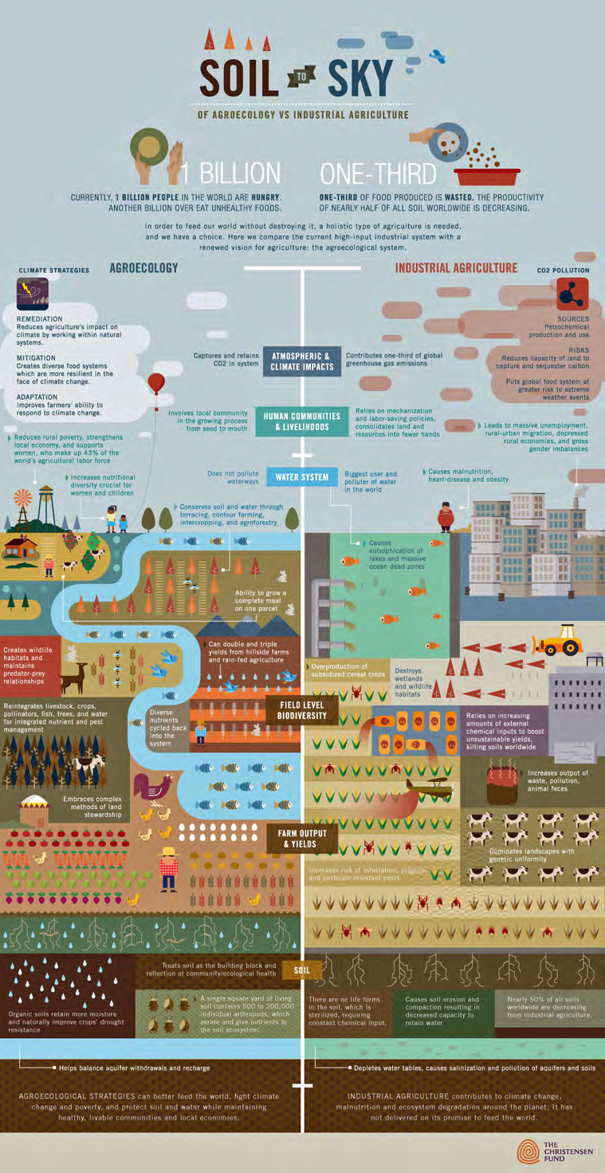
A major criteria of any reform should not be reduced to the current myopia around productivity and surveillance and control of biosecurity threats, but focused on the potential for farming systems that sequester carbon and are resilient against incursions of undesirable species. Regenerative practices, as advocated by the likes of AFSA, Farmers for Climate Action, Open Food Network, Young Farmers Connect, Charles Massy (farmer and author of Call of the Reed Warbler), and Paul Hawken (author of Drawdown) amongst many others, can make a significant contribution to climate change solutions while improving agricultural productivity.

Highly skilled workforce

Industrial agriculture has for decades contributed to the de-skilling of the workforce. Specialisation, outsourcing, and mechanisation have been part and parcel of the rise of monocultures of plants and animals, as commodity production demands ever-greater homogeneity in long supply chains. Current efforts to digitalise agriculture will further contribute to this trend, with continued loss of employment opportunities and decreasing dignity and value in the remaining jobs in agriculture.

If the Government is serious about a workforce strategy, it should put the interests of workers first and write a strategy to stop the continual erosion of quality occupations as employers try to reduce their costs at workers’ expense. Agrarian intellectual Wendell Berry perhaps said it best when reflecting on the past half century’s loss of workers from farms, saying that farms need ‘more eyes per acre’, not less. Human interactions with agroecosystems are some of the best biosecurity we have - people who can see that systems aren’t healthy, are out of balance, and are vulnerable to invasion of disease and pestilence.

Sustainable investment

The primary area of investment needed to address biosecurity concerns is a shift in production practices that create or increase the risk of disease and invasive species. Farmers using industrial methods need financial and educational support to transition from high-risk monocultures of plants and animals to biodiverse and ecologically sustainable farming practices.

Research should shift from downstream protection to upstream drivers of biosecurity risks. Funding for this research should be independent - a system that funds agrichemical suppliers to research the safety of agrichemicals fails utterly in its obligations to the public good. Participatory action research with farmers as lead investigators is a well-established methodology to deepen farmer knowledge and democratic participation in matters with a material impact on their lives and livelihoods while contributing to healthier systems overall.

Stronger partnerships

Article 18 of the UN Declaration on the Rights of Indigenous Peoples (UNDRIP) assures Indigenous Peoples’ right to participate in decision making in matters that may affect their rights. Article 19 requires that states must ‘obtain free, prior and informed consent before adopting and implementing legislative or administrative measures that may affect them.’ Biosecurity controls can have unintended and/or perverse consequences such as restricting Indigenous Peoples from access to traditional lands and genetic resources used for medicine, food, fibre, and practising culture. Article 24 of the UNDRIP specifically protects their right to these resources. Aboriginal and Torres Strait Islander Peoples are not just strategic partners in a biosecurity strategy, they are rights holders and should have opportunities to lead discussions and decisions made about their Country and native plants and animals. The NBC should:

- Apply a rights based framework to indigenous food and land management, and across the food system more broadly, by fulfilling the obligations outlines in the Nagoya protocol and the UN Declaration on the Rights of Indigenous Peoples (UNDRIP)
- Support the First Nations Bushfood and Botanical Alliance Australia Statement and ensure First Peoples are the leaders of policy and decision making in relation to food and land management
- Learn from other jurisdictions e.g. Victorian Traditional Owner Native Foods and Botanical Strategy to align the National Biosecurity Strategy with the rights of First Peoples

Small-scale farmers are also assured certain rights under the Declaration on the Rights of Peasants and Other People Working in Rural Areas (UNDROP).
1. For the purposes of the present Declaration, a peasant is any person who engages or who seeks to engage alone, or in association with others or as a community, in small-scale agricultural production for subsistence and/or for the market, and who relies significantly, though not necessarily exclusively, on family or household labour and other non-monetized ways of organizing labour, and who has a special dependency on and attachment to the land.
2. The present Declaration applies to any person engaged in artisanal or small-scale agriculture, crop planting, livestock raising, pastoralism, fishing, forestry, hunting or gathering, and handicrafts related to agriculture or a related occupation in a rural area. It also applies to dependent family members of peasants.
Article 2.3 requires that:
States shall consult and cooperate in good faith with peasants and other people working in rural areas through their own representative institutions, engaging with and seeking the support of peasants and other people working in rural areas who could be affected by decisions before those decisions are made, and responding to their contributions, taking into consideration existing power imbalances between different parties and ensuring active, free, effective, meaningful and informed participation of individuals and groups in associated decision-making processes.
We note that the National Biosecurity Reference Group includes a very limited number of high level industry groups, and no representation from Indigenous Peoples nor small-scale farmers:
Australian Banana Growers’ Council
CSIRO
Freight and Trade Alliance
Invasive Species Council
National Farmers’ Federation
Rural Research and Development Corporations representative - Australian Pork Limited
Seafood Industry Australia
Torres Strait Regional Authority
AFSA supports the NBC’s proposal to ‘review governance arrangements to ensure they include relevant stakeholders’, and calls upon our rights to insist that the NBC ensures that Indigenous Peoples and small-scale farmers have a seat at decision making tables, including on the Reference Group. In particular, the Government must ensure that representatives of farmers, producers and local communities are involved in inclusive identification of priority animal and plant pests and diseases and the choice of feasible and measurable indicators in relation to their prevention and control.
The NBC proposes to strengthen the involvement of environmental agencies and deepen international partnerships. We have already highlighted the glaring omission of mention of One Health in the proposed Strategy. One Health should be expanded to be more inclusive of the ministries and professionals responsible for wildlife, biodiversity, natural resource management, ecosystems, and the environment.
Expansion includes partnerships, programmes and ongoing collaborations including the Global Framework for Transboundary Animal Diseases Regional Steering Committee, the Regional Tripartite Coordination Group plus UNEP, the Asia and Pacific Commissions (Animal Health and Production, Plant Protection, Forestry), and within regional economic communities (ASEAN, South Asian Association for Regional Cooperation, and the Pacific Community), to name a few. As many of the technical challenges at hand are linked to wildlife management and issues at the human-wildlife-livestock interface, natural resource managers can contribute significantly to improved One Health collaborations.

Coordinated preparedness and response
One Health can also be adopted to mitigate the various negative externalities of agricultural
pest management, including Fall Armyworm and desert locust. Comprehensive strategies need to be
developed to defuse the impacts of crop protection on human, animal and environmental health (including zoonotic disease emergence). In programmes that address transboundary plant pests/diseases, Australia must favour tools and technologies that represent no or minimal public health risks.

These include agroecological farming tactics, crop/farm diversification schemes. The FAO is working to assist in benchmarking agrichemical pollution levels across the human- animal - environment interface and in unveiling causal patterns between pollutant exposure, disease (zoonotic, vector-borne) emergence and (non-communicable) human diseases.

Support for public and private animal health services that efficiently and effectively control vaccine preventable diseases and employ participatory One Health approaches to develop feasible and appropriate biosecurity practices in high-risk populations would yield significant return on investment. The multiple benefits of such an approach include: i) enhanced disease surveillance sensitivity across diverse livestock production systems as mortality becomes a rarer event and producer trust in animal health services increases; ii) decreased greenhouse gas emissions through improved livestock productivity; iii) improved household food and nutrition security due to increased income and improved access to animal-source food; and iv) decreased spread of disease from domestic animals to wildlife.

Integration supported by technology, research and data

Across our region, smallholders’ organisations are facilitating farmer-to-farmer knowledge exchanges in field schools and workshops. In Timor Leste, MOKATIL’s peasant organisation members such as UNAER train farmers in leadership and agroecology following Vía Campesina/Paolo Freire methodologies. SPI facilitates School of Agroecology and Seeds field days, and in 2016, hosted an exchange with the Korean Women Peasants Association (KWPA) in Indonesia for cross-cultural knowledge sharing of agroecology, and the struggle for the right to peasants’ seeds. At the Amritabhoomi Centre in the southern State of Karnataka, India, La Vía Campesina hosts agroecology schools to support the growth of young farmers, and in Australia, AFSA commenced Agroecology Workshops hosted by farms in diverse geographical settings across the country in 2021.

But economic, political, knowledge, and cultural lock-ins can limit the ability of farmers to shift to agroecology. Agroecology tends to be delegitimised by actor networks whose theories of change stymie such transitions.
Strong beliefs among scientist, industry, and government elites in the power of science and technology to overcome climate constraints are leading to agroecology being ignored (Iles 2020: 5).
Governments and the Agribusiness Industry are pushing digitalisation to solve the multiple crises of climate change and biodiversity loss with the attendant biosecurity threats. On the input side, agribusinesses are joining the trend of getting farmers to use their mobile phone apps to supply them with data, on the basis that they can give ‘advice’ to the farmers. On the output side, big e-platform corporations can be seen buying their way into the sector and taking control of food distribution. Together, they favour the use of chemical inputs and costly machinery, as well as the production of commodities for corporate buyers not local markets. They encourage centralisation, concentration and uniformity, and are prone to abusing their power and monopolisation. As we have already said, small-scale farmers are best placed to ‘surveill’ their land and report issues to authorities, not corporations looking to profit from farmers and governments.

Delivering access to and facilitating the use of appropriate technology that drives improved productivity, animal welfare and environmental stewardship through effective access to information and services, tailored insurance products and more diverse market options are crucial aspects of agricultural development in the 21st century. Indeed, online marketing of agricultural produce has grown significantly across the Asia Pacific region during the COVID-19 pandemic. However, it is essential that these innovations also be accompanied by rigorous investigation of human and environmental rights and frameworks concerning the ownership and use of the data generated.

2. ROLES WITHIN THE BIOSECURITY SYSTEM
– Can you see your current role within the bio­security system reflected in the consultation
Draft?

No. We do not see the interests of small-scale farmers nor communities affected by intensive livestock production or horticultural monocultures reflected in this draft. Although Indigenous Peoples’ interests are noted, we have concerns about how well their participation will be ensured in addressing them.

– Do you think the ‘How our biosecurity system works’ diagram (page 15) reflects your role and
responsibilities in the biosecurity system?

It is difficult to see where small-scale farmers fit in the diagram, as our members don’t identify with ‘Industry’ as represented by large-scale agribusiness at the production, processing, nor distribution levels, though of course as farmers they are part of the agriculture sector. AFSA asserts that our members belong to the stakeholder categories for ‘Industry’, ‘Research Organisations’, and ‘Individuals, businesses and communities’ (and our non-farming members belong to the latter two).

‘Research and capacity building: Maintaining capacity to prepare for, detect and respond to pests, weeds and diseases, and the management of those already established. Includes support for research and innovation to underpin Australia’s science-based approach to biosecurity’ - AFSA submits that agroecological farmers and Indigenous Peoples have been and are taking approaches to biodiversity and maintaining resilient agro-ecosystems that precede the need for biosecurity, but this is not reflected in the NBC’s articulation of the ‘biosecurity system’, as per our opening comments in this submission.

‘On the ground: Performing tasks for everyday management of biosecurity risks. Includes surveillance, complying with biosecurity obligations and managing pests, weeds and diseases. Contributing to the protection of the Australian environment and economy through practical biosecurity measures’ - this description of what happens ‘on the ground’, that is, on farmers’ land, again starts too far downstream. Agroecological farmers fundamentally support biodiverse and resilient agroecosystems that are not easily made host to pests, weeds, and diseases, and this form of farming must be supported and promoted to have any hope of addressing the increasing biosecurity threats posed by more than half a century of industrial agriculture.

If not, what amendments should be made?

We have taken the six action areas and aligned stakeholders as presented in the graphic on page 15 of the consultation draft and proposed amendments in the table below.

Original | Revised | Australian  Govt | State, territory, and local govts | Industry  [Needs to include small-scale producers | Representative Bodies (e.g. industry, environmental,  natural resource management and  community groups) | Research Orgs | Individuals, businesses and communities
Federal regulatory functions  Managing matters relating to the movement of people and goods at the national border. Regulating biosecurity controls to facilitate trade and market access, and fulfiling international convention obligations, including monitoring and reporting pest and disease status and protecting biodiversity. | Federal regulatory functions  Fulfilling international convention obligations, including protecting biodiversity, promoting One Health, upholding UNDRIP and UNDROP, following the Nagoya Protocol, and monitoring and reporting pest and disease status. Regulating international trade to manage biosecurity risk. Managing matters relating to the movement of people and goods at the national border. | X | XX
Research and capacity building  Maintaining capacity to prepare for, detect and respond to pests, weeds and diseases, and the management of those already established. Includes support for research and innovation to underpin Australia’s science-based approach to biosecurity. | Research and capacity building  Support for research and innovation in agroecology and opportunities to learn from Indigenous knowledges and practices of caring for Country. Building capacity to develop and manage ecologically-sound agro-ecosystems that are more resilient in the face of rising biosecurity threats. Building capacity to detect and respond with systemic reforms to pests, weeds, and diseases. | X | XX | X | X | X | XX
On the ground  Performing tasks for everyday management of biosecurity risks. Includes surveillance, complying with biosecurity obligations and managing pests, weeds and diseases. Contributing to the protection of the Australian environment and economy through practical biosecurity measures. | On the ground  Performing tasks for everyday management & fostering of biodiversity to reduce biosecurity threats. Includes agroecological farming for diversity and resilience, as well as constant monitoring of agro-ecosystems as well as unmanaged ecosystems, and co-managing pests, weeds and diseases with government support. Contributing to the protection of Country & communities through proactive ecologically-sound measures and practical biosecurity measures. | X | X | X | X | X | X
Awareness and information  Raising awareness and understanding of the biosecurity system and everyone’s roles and responsibilities. Including publishing information about Australia’s biosecurity system and responsibility for emergency response communications. | Awareness and information  Raising awareness and understanding of living in harmony with Nature and protecting biodiversity to reduce biosecurity risks, which is everyone's role and responsibility. Including publishing information about practical ways to protect biodiversity and Australia's biosecurity system, and responsibility for emergency response communications. | X | X | X | X | XX | XX
Leadership and coordination  Providing leadership and coordination to proactively manage biosecurity risk reduction and analysis. Includes developingpartnerships with biosecurity participants and fostering biosecurity awareness. | Leadership and coordination  Providing leadership to proactively manage healthy and resilient ecosystems to deter pests, weeds, and disease. Providing coordination to proactively manage biosecurity risk reduction and analysis. Includes developing partnerships with First Peoples and small-scale farmers as well as inter-departmental alliances for a One Health approach to livestock production. | X | X | X | X | X | X
Domestic regulatory functions  Managing biosecurity within Australia’s border. Includes undertaking enforcement actions, regulatory interventions, emergency responses and negotiating and facilitating domestic trade. | Domestic regulatory functions  Managing biosecurity within Australia's border. Includes educative activities, enforcement actions, scale-appropriate regulatory interventions, emergency responses and identifying risks in domestic trade. | X | X
Original Stakeholders = X
Amended Stakheholders = XX

3. BIOSECURITY RISKS AND OPPORTUNITIES
– How regularly should the strategy be reviewed?

AFSA agrees with the proposal that the strategy be reviewed every six months. It is important that all stakeholders, not just government and big industry, have the opportunity to input at each stage.

– Are there any key risks and opportunities not captured in the consultation draft?

As outlined above, AFSA submits that biosecurity should not start at monitoring and surveillance, but rather start with prevention. We need to look at the sources of biosecurity risks, which often present themselves in the form of industrial and monoculture agriculture. These proven risks need to be mitigated through the education and promotion of agroecological farming methods that will help prevent biosecurity risks.

– Do any of the biosecurity risks or opportunities outlined in the consultation draft have additional implications for our 6 priority areas?

AFSA believes that biosecurity needs to be both ‘top down’ and ‘bottom up’. Whilst government policies and programs are essential to protect Australia from threats, we believe that the consultation draft does not provide correct weight to the ‘bottom up’ approach. It is those working on the land and farming each and every day who are in the best position to prevent, identify, mitigate and surveil biosecurity risks. Not enough emphasis has been placed on these elements within the strategy. It seems that somehow government agencies are expected to know what is going on ‘on the ground’, but it is the farmers who know, and who are our best allies against biodiversity threats, these farmers need to be more included as ‘partners’ in order for any strategy to be successful.

Additionally, AFSA feels that the mentions of climate change, COVID-19 and biodiversity loss in the draft consultation appear to be mere mentions, there is little follow through on these ideas with regard to actions/priority areas. There are two areas here that are worthy of mention, yet again, and they are First Peoples knowledge and agroecological farming methods as approaches that need to be explored further to mitigate the effects of biosecurity issues.

– How should we monitor and evaluate the success of the national strategy and implementation plans?

Monitoring and evaluation at the high level would seem to be about monitoring biosecurity threats as they appear and our surveillance and monitoring of them, with the hope that any threats are contained. AFSA thinks that we should aim higher than this.

AFSA submits that better monitoring and evaluation would be around on-ground preventative and mitigation strategies, working with farmers of all scales to help implement biodiverse and agroecological approaches to biosecurity. To measure the breadth of training available to develop integrated biosecurity plans and actual development of said plans, in other words, how many farmers (percentage wise or numbers) are you working in partnership with to help prevent biosecurity threats?

4. ACTIONS
– What are your views on the proposed initial actions?
See our detailed comments above, and short recommendations below.

Shared Biosecurity Culture
- Promote agroecological and regenerative farming practices that support biodiversity - including agricultural biodiversity
- Reference the Draft Global Biodiversity Framework to be ratified in Kunming, China in August 2022
- Reference Australia’s Strategy for Nature 2019-2030

Highly Skilled Workforce
- Develop a strategy for maintaining quality skilled occupations in agriculture and food systems, where people have autonomy and responsibility to understand complex ecosystems and production environments, and have capacity to read early signs of biosecurity threats

Sustainable Investment
- Provide financial and educational support for farmers to transition from high-risk monocultures of plants and animals to biodiverse and ecologically sustainable farming practices.
- Fund independent research into agroecological transitions, including participatory action research with farmers as key investigators.

Stronger Partnerships
- Apply a rights based framework to indigenous food and land management, and across the food system more broadly, by fulfilling the obligations outlines in the Nagoya protocol and the UN Declaration on the Rights of Indigenous Peoples (UNDRIP)
- Support the First Nations Bushfood and Botanical Alliance Australia Statement and ensure First Peoples are the leaders of policy and decision making in relation to food and land management
- Learn from other jurisdictions e.g. Victorian Traditional Owner Native Foods and Botanical Strategy to align the National Biosecurity Strategy with the rights of First Peoples
- Ensure that Indigenous Peoples and small-scale farmers have a seat at decision making tables, including on the National Biosecurity Reference Group.
- Ensure that representatives of farmers, producers and local communities are involved in inclusive identification of priority animal and plant pests and diseases and the choice of feasible and measurable indicators in relation to their prevention and control.
- One Health should be expanded to be more inclusive of the ministries and professionals responsible for wildlife, biodiversity, natural resource management, ecosystems, and the environment.

Coordinated Preparedness and Response
- Develop comprehensive strategies to defuse the impacts of crop protection on human, animal and environmental health (including zoonotic disease emergence). In programmes that address transboundary plant pests/diseases, Australia must favour tools and technologies that represent no or minimal public health risks.
- Support public and private animal health services that efficiently and effectively control vaccine preventable diseases and employ participatory One Health approaches to develop feasible and appropriate biosecurity practices in high-risk populations.

Integration Supported by Technology, Research and Data
- Support farmer to farmer knowledge sharing, agroecology workshops, and participatory action research projects in agroecology and regenerative agriculture.
- Conduct a study of farmer, producer, fisher and other resource owner legal rights in relation to digital data pertaining to their resources.
- Promote transparent agricultural data governance that ensures equal rights for family farmers and fishers.

– What other actions should be included to deliver our 6 priority areas, address biosecurity risks
and capitalise on our opportunities for change?

AFSA believes that the glaring gap in the delivery of priority areas, biosecurity risks and opportunities is actually working with farmers who are on their land each and every day. These are the eyes and ears of our industry. Whilst many ‘industrial’ scale farmers are represented by ‘industry groups’ this is often not the case with the large number of small scale farmers who often do not identify with specific industries.

Much of the work involved in preventing, mitigating and even identifying biosecurity risks needs to come from those who are hands on every day working on their farms, and the recognition of this needs to be brought to the fore in any national biosecurity strategy.

– How can you contribute to achieving our 6 priority areas?

AFSA, as outlined in our introduction, represents a large number of small-scale farmers across Australia. We are able to contribute to the achievement of biosecurity goals by communicating with and passing on educational and other information to our wide base of farmer members. We are also connected with a large number of allies who work throughout Australia’s food system and again see our role as information dissemination and practical education in regard to biosecurity issues.

We would welcome the opportunity to represent smallholders’ views and interests on the National Biosecurity Reference Group.

5. IMPLEMENTATION AND REVIEW
– How do you see your own and others’ roles changing into the future?

AFSA hopes that both our own role and those of others becomes more meaningful over time. We are not an industry group lobbying to protect our own industry’s interests, we represent a very large and diverse number of farmers and allies across all of Australia to whom biodiversity and biosecurity are of the utmost importance. We would like to continue to be involved not only in the implementation and development of strategies, but more importantly in research and development of preventative actions with regard to biodiversity. We believe that many of our farmer members would like to see a greater role played by those ‘on the ground’.

– What mechanisms should be established to ensure stakeholders are involved in the further development of actions and implementation planning?

AFSA believes that all stakeholders should at all times be able to have a say and ensure their voices are heard. Consultation needs to be open to First Peoples, individuals, farmers, and collectives, not just national bodies and large industry groups. As a starting point, any and all persons and organisations who have taken the time to submit to this review should be invited to comment at all stages of review. Further, comments should be sourced from all levels of the industry at all times, with no restriction on who is able to comment. Limiting input and comment only to ‘industry bodies’ and representatives is not a democratic way of hearing all voices. After all, the reality is that it is those on the ground who need to implement policies and are in the best position to provide practical and meaningful advice.

Provide your feedback through to National Biosecurity Strategy Have Your Say
– https://haveyoursay.awe.gov.au/national-biosecurity-strategy
If you have any questions, please email nationalbiosecuritystrategy@awe.gov.au

Routledge Handbook of Biosecurity and Invasive Species. 2021, p.4.
Wallace, R. 2016. Big Farms Make Big Flu, Monthly Review Press.
Wallace, R. 2018. ‘Duck & Cover: Epidemiological and economic implications of ill-founded assertions that pasture poultry are an inherent disease risk’, AFSA.
Routledge Handbook of Biosecurity and Invasive Species. 2021, p.8.
https://www.onehealthcommission.org/en/why_one_health/what_is_one_health/
https://www.fao.org/agroecology/home/en/
https://www.fao.org/3/i9037en/i9037en.pdf
For a greater understanding of how agroecology differs from regenerative agriculture, see AFSA’s post: https://afsa.org.au/blog/2021/06/28/13699/
https://www.who.int/news/item/01-12-2021-tripartite-and-unep-support-ohhlep-s-definition-of-one-health#
https://www.thelancet.com/journals/lancet/article/PIIS0140-6736(15)60901-1/fulltext
https://www.sciencedirect.com/science/article/pii/S0160412019305409
http://vsf-international.org/wp-content/uploads/2015/01/VSFE_Position_Paper_3_OneHealth_EN.pdf
https://www.fao.org/3/i9037en/i9037en.pdf
Wallace, et al. 2021: 195
Keesing, F. & Ostfeld, R. S. 2021. Impacts of biodiversity and biodiversity loss on zoonotic diseases; Proceedings of the National Academy of Sciences Apr 2021, 118 (17) e2023540118. (also available at doi: 10.1073/pnas.2023540118
FAO, 2022
FAO, 2022
FAO 2022
FAO 2022
https://www.foodstandards.gov.au/consumer/safety/Pages/Recall-of-frozen-mixed-berries.aspx
Keusch, G.T., Pappaioanou, M., Gonzalez, M.C. Scott, K.A. & Tsai P. 2009. Sustaining Global Surveillance and Response to Emerging Zoonotic Diseases. New York: National Academic Press.
Jones, K., Patel, N., Levy, M., Storegard, A., Balk, D., Gittleman, J.L., & Daszak, P. 2008. Global trends in emerging infectious diseases. Nature, 451, 990–993. (also available at doi:10.1038/nature06536).
https://www.fnbbaa.com.au/bushfood-symposium-statement-firstn
https://www.fvtoc.com.au/native-foods-and-botanicals
https://documents-dds-ny.un.org/doc/UNDOC/GEN/N06/512/07/PDF/N0651207.pdf
https://digitallibrary.un.org/record/1650694?ln=en
https://www.australiasnaturehub.gov.au/national-strategy
https://www.australiasnaturehub.gov.au/national-strategy
https://www.cbd.int/article/draft-1-global-biodiversity-framework
https://www.fnbbaa.com.au/bushfood-symposium-statement-firstn
https://www.fvtoc.com.au/native-foods-and-botanicals

